Oliver Collins-Cope

Richmond upon Thames College

U6 assignment 2

Table of Contents

Design 2

In production comments and notes: 7

Hex Update 7

Font sizing update 7

Slight adjustments on home page 8

JavaScript comments on saved animals (page 2) 8

Design Feedback 8

Changes 10

Btn.form in home page 10

Contact form 10

Evaluation of changes 10

Testing 10

Website Feedback 11

Optimisation 11

Review/Eval 11

# Design

Shown below is the design of my website, along with the feedback I received from my peers. Furthermore, it also includes a section where I detail changes I made to my design with justification and an evaluation of my changes, along with how I believe it improves my website and to what extent.

My design for my website:

|  |
| --- |
| Website Design |
| **Name:** Charity |
| **Website Purpose:**  To raise awareness for charity |
| **Website Target Audience:**  Older than 18  All genders  Pet owners |
| **Website Requirements:**   * Be at least 5 pages * Feature an image carousel/slide show and social media integration * Feature suitable images, text and at least 1 video * Use scripts in at least 1 way i.e. a booking/quote/email form |

|  |
| --- |
| Site Map |
| Upcoming plans ect  Contact info Donation  Information about previous charity things  Charity information  Home Page |
| **Description:**  The site will have 4 options for the user to travel to from the home page, while having navigation options on the side which will stay consistent across the site. |

|  |
| --- |
| Storyboard |
| A picture containing text  Description automatically generated  btn.form  This site is not owned or ran by Stichting Strays Meet Holland and is purely to raise awareness for it in another way.  Strays Meet Holland Awareness |
| **Description:**  The “TBD” boxes are to be determined/decided images for the site and they will be images the user can click on to go to the next page. The next pages will all follow the same format and I have included that this site is separate to the original site. The background matches that of the original site in order to maintain consistency for conveniences sake. |

|  |
| --- |
| Moodboard |
| **Website Colours**   |  |  |  |  |  | | --- | --- | --- | --- | --- | | Hex: #ce0d4ac | #e9e7e7 |  |  |  |   **Website Fonts**  I will be using “Arial Font” at 12px for my website as the normal text and” Lucida Sans” at 16px for my headers.  Images are to be determined however they will be centred around the charity such as where it is, and animals they have rescued as long as permission is given. Example of potential animals is as below.  A collage of a cat  Description automatically generatedA picture containing grass, outdoor, mammal, field  Description automatically generatedA collage of a dog and a cat  Description automatically generated with medium confidence |
| **Description:** The colours chosen are to stick to a neutral colour scheme which is the same as the original charity in order to stick to consistency. The grey I chose is to compliment the neutral colour the charity has and to slightly differentiate but not enough to throw anyone off. |

|  |  |
| --- | --- |
| Page #1 | Page Name |
| Info about image  Image carousel | |
| **Description:**  This page will feature an image carousel of different animals that the charity has saved and information available about the animal | |

|  |  |
| --- | --- |
| Page #2 | Page Name |
| A picture containing text  Description automatically generated  Information on charity  Credits for images social media links regarding charity | |
| **Description:**  Information on charity and links to different pages that the charity is related to. | |

|  |  |
| --- | --- |
| Page #3 | Page Name |
| Anything they want me to add  Anbi certification  Image of animal | |
| **Description:**  Here I will explain that the charity is anbi certified and explain what that is, alongside an image of an animal and anything the charity wants me to add | |

|  |  |
| --- | --- |
| Page #4 | Page Name |
| Asking users to donate to charity here  Links to Instagram account where more info can be found  image of the account  Donate here (clickable button) | |
| **Description:**  Here I will add a clickable button that links users to the donation page of the charity, as well as adding something to track how many users click on the donation. I will also link my Instagram account for the charity which I am doing for my other unit. | |

|  |  |
| --- | --- |
| Page # | Page Name |
|  | |
| **Description:** | |

|  |
| --- |
| Scripts |
| **Description:**  Added auto image carousel script |

## Design Feedback

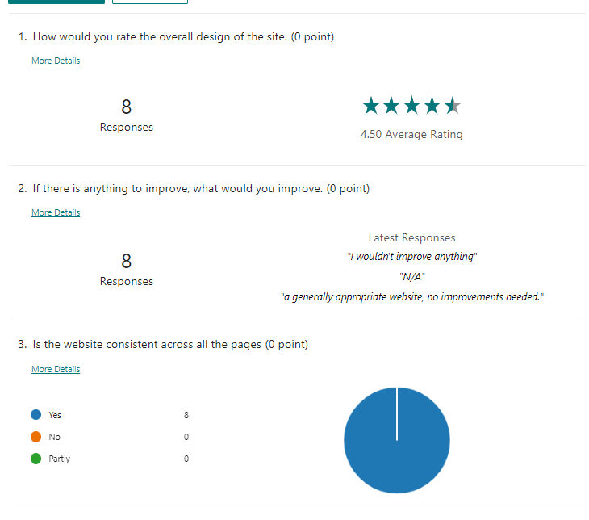

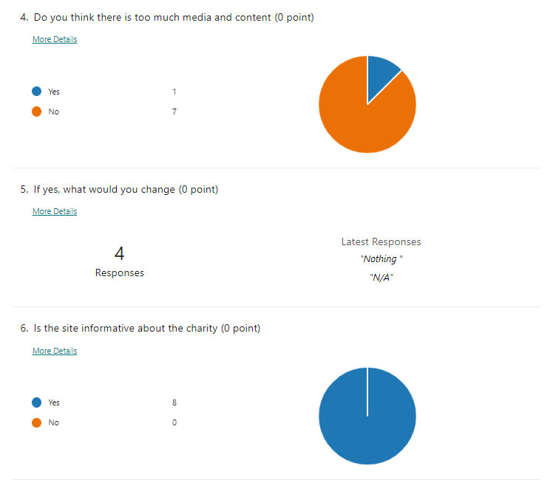

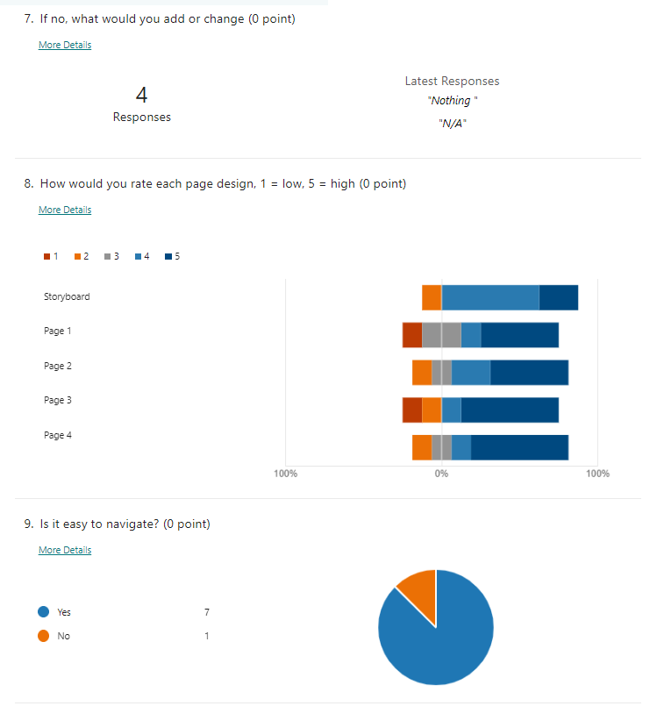

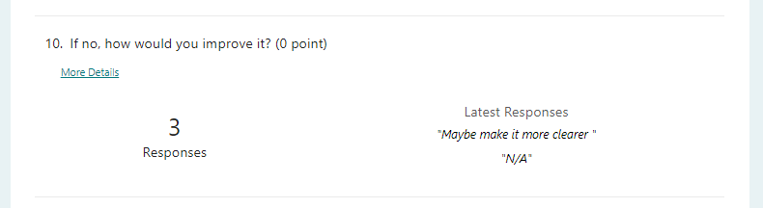

This is the feedback I received from my peers. Although it does not have clear feedback regarding changes, there are some I have identified that need to be made and I will add those in, while mentioning them below. Following that, I will add an evaluation of my changes and why/how I think it improves and changes my site

## Changes

These are some of the changes that I made during the production of my website.

### Btn.form in home page

I moved the button for the contact form to the bottom of the page as I found that this looked nicer and was easier to implement.

### Contact form

I added a contact form page, which upped my total pages to a number of 6. I added this because I realised that in order to fulfil all the criteria, I was required to set this up, and I also added javascript alerts to validate whether the user has filled in all the required fields.

### Hex update

I changed the background colour of my site to closer match the Strays Meet Holland original site that I am raising awareness for. This is to try and stay consistent across the sites in order to provide a stronger connection and a more professional feel for the site. The new Hex code is #d1c69b which has a slightly darker shade.

|  |
| --- |
|  |

### Font sizing update

My font sizing has also changed quite regularly, and currently most of the text on my pages sits at around 20px, as opposed to the 12px that I had originally chose. This is because once I started developing my page, it came to my attention that 12px was far too small and only worked on my word document, but not my website. The aim of this change was to make my text more readable.

### Slight adjustments on home page

On my home page, the position of my text and image on the top also flipped positions as I thought this would look nicer, and it would remain consistent with my information page, page 3, which would look more professional.

### JavaScript comments on saved animals (page 2)

To implement my image carousel in my page I used JavaScript to create a script which has a function that I call at the start of it, and then wrote the rest of my script below it.   
It declares two variables, “i” and “slides”, and assigns my slideshowImg class to “slides” using document.getElementsByClassName(“slideshowImg”)

From there it starts a for loop where it declares “i” as 0, and checks if it is shorter than the slide length, and adds 1 if it is, and then sets the display to none so it disappears.

After running this, it adds one to “slideIndex” and then checks if slide index is larger than slides.length. From here it changes the display type to block so it shows the image and adds a timeout before the code runs again in order to achieve the waiting time.

### JavaScript validation for contact form

As mentioned above, I have added a contact form to my website in which I added JavaScript validation that adds an alert asking users to fulfil all the required boxes and only allows users to submit once the necessary boxes are fulfilled. Furthermore, it adds an alert that lets the user know the form was submitted successfully.

## Evaluation of changes

Overall, I believe that each of the changes I have added improve my website in different ways, from making it more readable, to adding a whole page which allows the user to contact through a form.

I believe that these quality-of-life changes and general improvements of the site are well justified by themselves, however I will also add some notes regarding them.

### Contact form button

The change of location for the contact form button makes it able to stand out more without seeming insignificant as it might when pushed into the corner on the side. In addition to this, the bright colours of the button bring the users attention to it and alert them that they have the option of this contact form.

### Contact form

The contact form was added to the site as it allowed for users to contact the site owner as required in the specification, and with the extra validation I also think this makes a great addition to the page, enhancing the users experience and allowing them to make request or comments to the email the contact form is linked to

### Hex update

This change was made in order to add a greater similarity to the original site that the colours of mine are based on, and also in order to add a greater contrast to the text and provide better accessibility features.

### Font sizing update

For my font, I decided to increase the size as the original size I had chosen was only large inside of the word document, and I believe that this change increased the readability of my website, along with the accessibility due to the larger text which makes it easier for users with worse eyesight to read. I believe this change therefore improved my site and helps to fulfil the criteria.

### Home page adjustments

These changes are minimal however they help to provide consistency and therefore I believe it is justified to do so as it allows for a smoother experience across the different webpages, improving my site from the design.

### JavaScript slideshow

The JavaScript slideshow I have in my website helps to display different images of animals the charity has saved, adding more media content that does not overload the user as it all remains in the same place. Furthermore, it also fulfils the criteria of the assignment and is different from my design as I was not sure at the time what kind of scripts we were going to add and what was possible for me to create.

### JavaScript validation for contact form

The JavaScript validation for the contact form that I added adds an extra element to my website which was not previously mentioned in the design. By checking whether the user had filled out the required forms for submission and providing an alert depending on whether they had filled out which helps the user to know whether they had successfully submitted the contact form or not. This extra validation provides great increase to quality of life in my website and overall helps to improve the user’s experience.

# Testing

|  |  |  |  |  |
| --- | --- | --- | --- | --- |
| **Test #** | **Description** | **Expected Results** | **Actual Results** | **Comments** |
| **1** | The 4 images on the home page lead to the 4 separate pages | Pass | Pass | Leads to the 4 respective pages |
| **2** | The video will play on the donate page | Pass | Pass | The video plays |
| **3** | The contact form will not submit due to lack of required information | Pass | Pass | Form does not submit. See image below |
| **4** | The image carousel will change images every few seconds | Pass | Pass | Images change |
| **5** | Information button takes user to information page | Pass | Pass | Loads information page |
| **6** | Home page will load from home button | Pass | Pass | Home page loads from the button |
| **7** | Home page will load when clicking on the purple text at the top | Pass | Pass | Loads home page successfully |
| **8** | Donate here button loads donation page for official charity | Pass | Pass | Leads to external site of donation page |
| **9** | Contact us button dims on hover and when clicked on is smaller for effect | Pass | Pass | Button dims and gets smaller on click. See image below |
| **10** | Hovering over images on home page menu gives text displaying what the page is about and makes the image g o white slightly/transparent | Pass | Pass | Image goes slightly transparent and text appears |

# Website Feedback

## Optimisation

Based on the feedback I have received the primary change I will make is to centre the form on my page. I currently prefer the way that the social media text appears and I will not be changing it.

Here is the new and improved design of the website, which is different to what is was before here.

# Review/Eval